Porting the ArbotixPro
This document will outline the process of porting the ArbotixPro to STM32F4-discovery board.

ArbotixPro Hardware summary
List of components available on the ArbotixPro is listed in Table 1.
Name | Function
CPU | Main micro controller
USB | Communication with higher level interface such as the intel Edison or raspberry pi
IMU | 3 Axis Gyro, 3 Axis accelerometer
Servo control | Half duplex buffer
Xbee | Xbee interface
Voltage Regulation | 3.3V and 5V
Clock | External 8Mhz clock
Jtag | External Jtag contacts
Other interfaces | Switches, Buzzer, LEDs
Table 1 List of components on the ArbotixPro

CPU
The ArbotixPro is based on STM32F103 an ARM Cortex-M3 MCU.

USB
The ArbotixPro uses a USB interface to connect to higher level controller such as the Raspberry Pi and the Intel Edison. The USB connection is simply translated to a USART interface on the MCU using a FT232 chip.
Note, USB_DXL is a 4 pin adapter, this could be used to interface instead of the micro usb terminal.
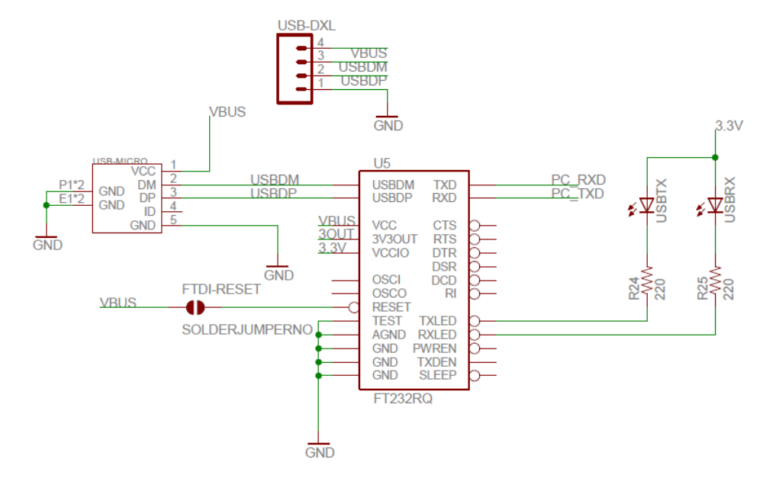
Table 2 USB connection circuit
Function | Quantity | Part No.
USB to UART | 1 | FT232RQ
Table 3 Components list
Pin names | Functions | MCU pin map, Pin function
PC_RXD | Transmit to USB | PB11, UART3
PC_TXD | Receive from USB | PB10, UART3
Table 4 Pin mapping to the MCU

IMU
The Accelerometer and the gyroscopes are accessed via SPI bus, two chip select pins are used to select the parts.
Figure 1 shows the circuit used for the IMU, Table 5 lists the part numbers and Table 6 lists the pins required.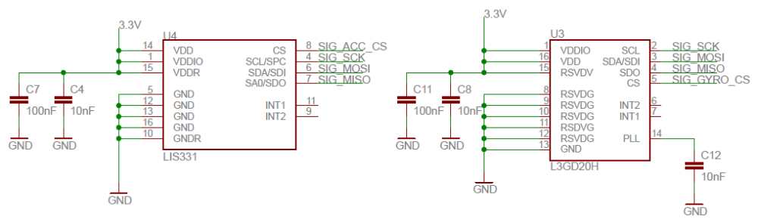
Figure 1 IMU circuitry

Function | Quantity | Part No.
Accelerometer | 1 | LIS331
Gyro | 1 | L3GD20H
Table 5 List of componenets
Pin names | Functions | MCU pin map, Pin function
SIG_ACC_CS | Accelerometer Chip select | PC10, DIO
SIG_GYRO_CS | Gyro chip select | PC11, DIO
SIG_MISO | SPI | PB14, SPI2_MISO
SIG_MOSI | SPI | PB15, SPI2_MOSI
SIG_SCK | SPI | PB13, SPI2_SCK
Table 6 Pin mapping to the MCU

Dynamixel Servo Control
The Servo controller accommodates RS485 and TTL interface

Power
This circuit (Figure 2) is responsible for powering the servo motors, VIN is 12V, and is controlled by ENABLE_DXLPWR pin. Table 7 and Table 8 lists the component part numbers and used pins.
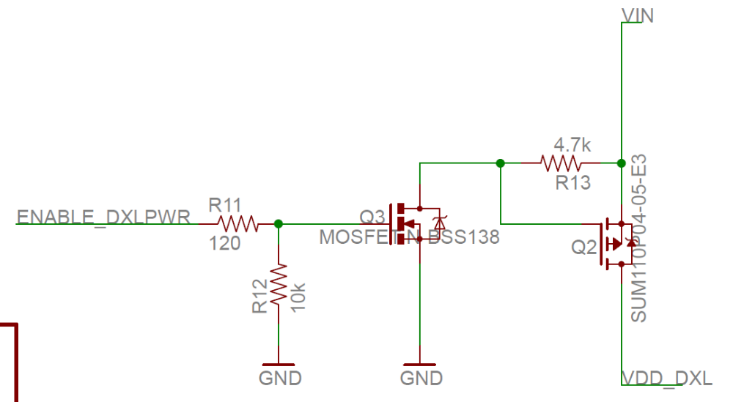
Figure 2 Power circuit for Dynamixel servos

Function | Quantity | Part No.
N MOSFET | 1 | BSS138
P MOSFET | 1 | SUM110P04-05
Table 7 List of component required
Pin names | Functions | MCU pin map, Pin function
ENABLE_DXLPWR | Turn on the power to the servos | PB8-D4
VIN | Main power supply | 12V
VDD_DXL | Power going into the Servos | To Servo
Table 8 Pin mapping to the MCU

TTL
TTL interface is constructed using Tristate buffers and two low pass filters, Figure 3 shows the TTL buffer circuit, Figure 4 shows the connection to the MCU. The AND gate shown in Figure 3 is used to integrate this circuit with the RS-485 circuit, if RS-485 is not required then it can be omitted, it will be omitted for this project. Table 9 shows the list of components required to build this circuit. And required pins are listed in Table 10.
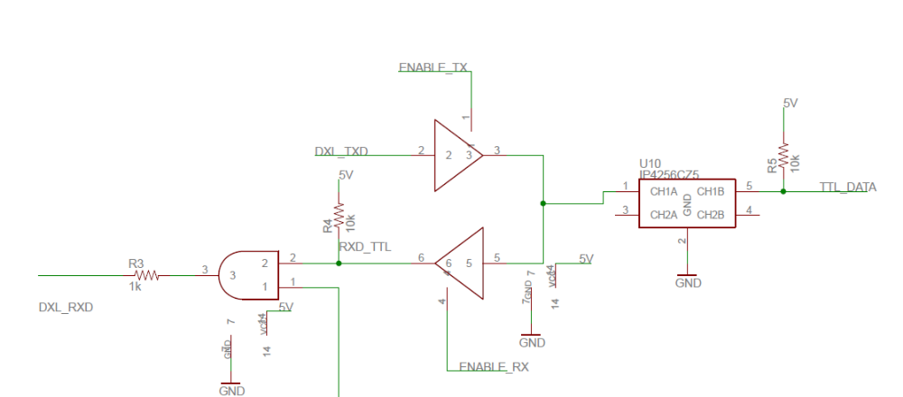
Figure 3 Dynamixel servo TTL interface
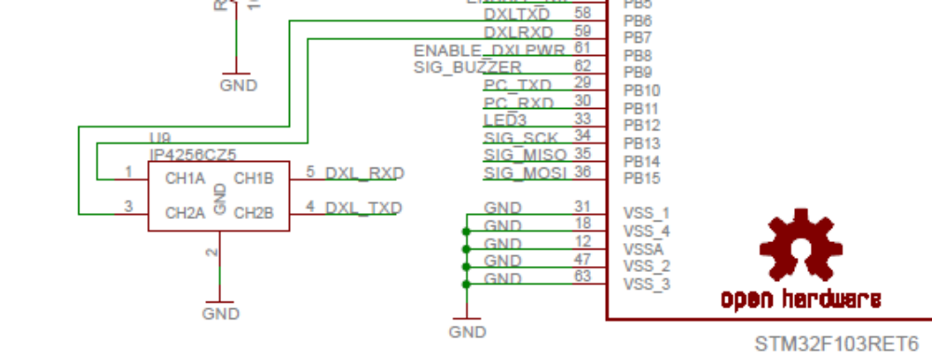
Figure 4, LPF(U9) connections to the MCU, DXL_RXD and DXL_TXD are connected to TTL circuit in above previous circuit
Function | Quantity | Part No.
Tristate buffer | 1 | 74HC126D,653
LPF | 1 | IP4256CZ5
Table 9 Parts needed to complete this circuit
Pin names | Functions | MCU pin map, Pin function
DXL_RXD | Receive | PB6, UART 1
DXL_TXD | Transmit | PB7, UART 1
Enable TX | Enable TX | PC9, DIO
ENABLE_RX | Enable RX | PB5, DIO
Table 10 Pin mapping to the MCU

RS485
Rs485 is ignored for this port, because the AX12 servo motors use TTL.

Xbee
Xbee interface is provided by the ArbotixPro, the pin map is listed below. Note the Xbee is enabled using ENABLE_ZIGBEE pin.
Pin names | Functions | MCU pin map, Pin function
ZIGBEE_RXD | Receive | PD2, UART5_RX
ZIGBEE_TXD | Transmit | PC12, UART5_TX
ENABLE_ZIGBEE | Enable Zigbee module | PC8, DIO

Voltage Regulation

Clock

Jtag

Hardware compatibility
This section will propose a strategy to make the STM32F4-Discovery board compatible with the ArbotixPro, alternative hardware will be suggested.
Name | Function
USB | Communication with higher level interface such as the intel Edison or raspberry pi
IMU | 3 Axis Gyro, 3 Axis accelerometer
Servo control | Half duplex buffer
Xbee | Xbee interface
Voltage Regulation | 3.3V and 5V
Clock | External 8Mhz clock
Jtag | External Jtag contacts
Other interfaces | Switches, Buzzer, LEDs

Peripherals

STM32F4-Discovery
The STM32F4-Discovery board i

USB
FTDI MM232R DEV MODULE is a USB to UART converter module uses FT232RQ chip, which can be used to replace the ArbotixPro usb interface.
Note, this module has a USB B plug.
PIN SWAP TABLE

IMU

Servo Control

Xbee

Voltage Regulation

Other Interfaces

